How to open .dB file in DB Schema software  
1) 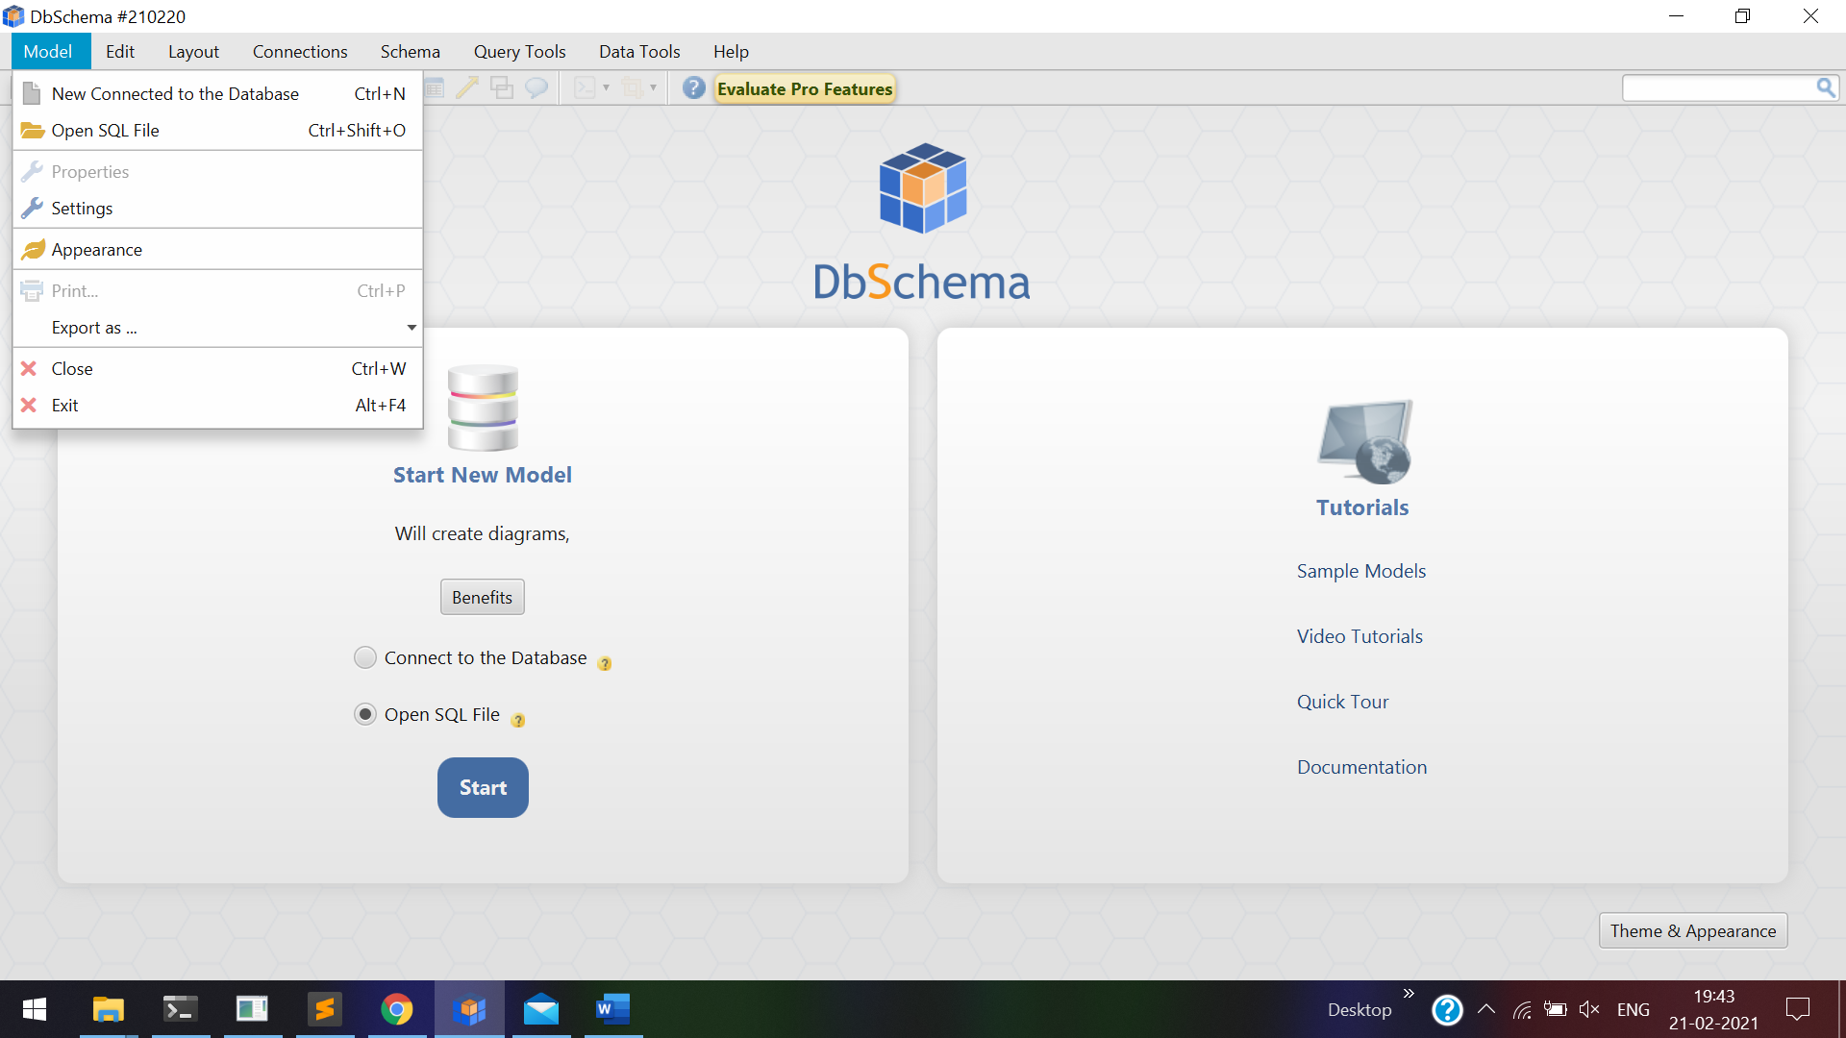

Click new connection

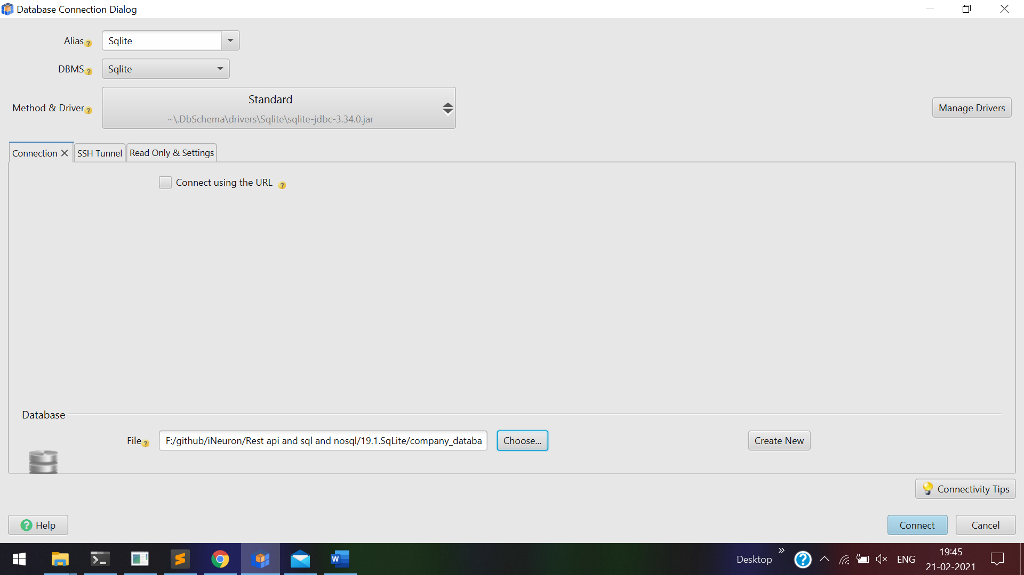

Select **Sqlite** in **DBMS**